CDA 4203L

Computer System Design Lab

Lab 4 Report

Vending Machine FSM

|  |  |
| --- | --- |
| Today’s Date: | 2/20/2022 |
| Team Members: | Thomas Bivins |
| Patrick Cook |
| Josue Lugo Roldan |
| Work Distribution: | Briefly explain the tasks completed by each team member  Thomas Bivins: Debugging and Report  Patrick Cook: Implementation and Debugging  Josue Lugo Roldan: Debugging and File Organization |
| No. of Hours Spent: | 7 hours |
| Exercise Difficulty:  (Easy, Average, Hard) | Average |
| Any Other Feedback: | N/A |

**Problem 1:** Show the state diagram of your vending machine controller. Briefly explain how the design works. *Use as many pages as needed.*

**Problem 1:** Include the Verilog code of (a) FSM; (b) Testbench; and (c) Simulation waveforms. *Use as many pages as needed.*

*a. FSM*

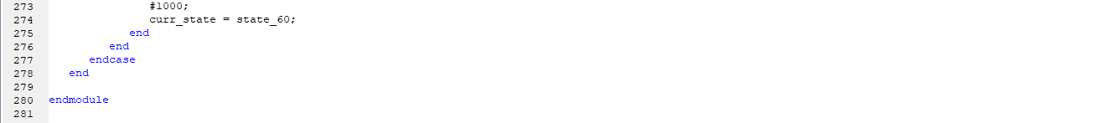

*b. Testbench for (45 cent case)*

*Waveform 2: 35 cents*

*Waveform 3: 45 cents*

**Problem 2:** Include (a) the **.ucf** file; and (b) synthesis report. *Use as many pages as needed.*

1. ***.ucf file***

1. Synthesis report

